Survey Results and Management Recommendations
For Phragmites and Quagga Mussels
In the Cheboygan River Watershed

Tip of the Mitt Watershed Council
November 2009

Table of Contents

Page
Introduction 3
Biology and Impacts 4
Phragmites 4
Quagga mussels 5
Survey Methods and Results 7
Phragmites 7
Quagga mussels 8
Discussion 10
Management recommendations 11
Prioritizing management 12
Management evaluation 13
Literature Cited 14
Appendix 1. Maps of survey results 15
Figure 1. Phragmites in the Cheboygan River Watershed. 15
Figure 2. Quagga mussel in the Cheboygan River Watershed 16
Figure 3. High priority areas for management 17

INTRODUCTION

To date, an excess of 180 non-native aquatic species have been documented in the Great Lakes region and additional non-native species are appearing every year. Some non-native species become so problematic in terms of damage to the environment, economy and even human health, that they are labeled “invasive” species. Two invasive species of great concern in the Great Lakes region are Phragmites (Phragmites australis), a tall grass, and quagga mussels (Dreissena rostriformis), related to the invasive zebra mussel. Invasive Phragmites and quagga mussels are now common throughout most of Lake Michigan and Lake Huron. However, little was known until recently about their spread into the inland areas of the Northern Lower Peninsula of Michigan.
With funding provided by the National Fish and Wildlife Foundation, the Tip of the Mitt Watershed Council surveyed the major thoroughfares of the Cheboygan River Watershed, both on land and in the water, to assess the status of invasive Phragmites and quagga mussels. Large lakes, rivers, and major roads were surveyed during the 2008 and 2009 field seasons. Surprisingly, the occurrence of both invasive species was rare to nil in areas surveyed despite the high volume of boat and road traffic. Therefore, management strategies should focus primarily on preventing the introduction or spread of these invasive species within the Cheboygan River Watershed.
Management of invasive Phragmites and quagga mussels in the Cheboygan River Watershed must be both comprehensive and collaborative to be successful. Natural resource managers, lake association members, local government officials, and others must be engaged and informed regarding the dangers associated with these invasives and educated in terms of identification and control methods. Vigilance must be maintained throughout the watershed’s waterways, roadways and all locations in between, to prevent the spread or introduction of these undesirable species. Action must be taken swiftly whenever and wherever the invasive species are found in the watershed.

BIOLOGY AND IMPACTS

Phragmites
Phragmites australis is a perennial, tall grass species attaining up to 15 feet in height that is commonly found in wet areas throughout Michigan, whether along lake and river shorelines, amidst wetlands, or in roadside ditches. There is a native variety of Phragmites that intermingles with other plants and coexists in harmony in our native ecosystems, but there is also an invasive type that dominates the wet areas it grows in, crowds out native plants, and alters the ecosystem in myriad forms ranging from diminished waterfowl habitat to changes in local hydrology. Both are the same species, though the native variety has been given the sub-species name Phragmites australis americanus. Native Phragmites has been in North America for thousands of years, whereas the invasive type was probably introduced in the 1870s (Meyerson et al. 2009). Native populations appear to be declining while the invasive type expands.
Invasive Phragmites has been a problem in the southern Lower Peninsula of Michigan for a number of years, but only recently began to appear in the Northern Lower Peninsula. Once established, it can become a monoculture and dominate wet areas in the period of a few years. It has been a highly successful invader for a number of reasons. It has a high biomass and is tolerant to a wide range of physical and chemical conditions (Meyerson et al. 2009). Studies show that invasive Phragmites outcompetes other wetland plants for available light, allowing little to no sunlight to penetrate to the ground. Furthermore, invasive Phragmites spreads readily by producing large numbers of seeds, rhizome fragmentation, and surface runners.
Phragmites has come to the forefront of water resource management in the northern Lower Peninsula because the invasive type has taken root in many locations, particularly along Great Lakes and directly connected inland lake shorelines. Recently, organized groups on nearby Beaver Island and in the Lake Charlevoix area have carried out projects to control Phragmites on their shorelines. As the invasive type becomes more prevalent along Great Lakes shorelines, it is expected to become more common in inland areas.

Quagga Mussels
Quagga mussels, belonging to the same taxonomic family (Dreissenidae) as the invasive zebra mussel, were first documented in the Great Lakes in 1991 (Mills et al. 1996). Throughout a 10 year time period, quagga mussels gradually displaced zebras and now dominate the benthic communities of Lake Michigan, comprising nearly 98% of the total population (Nalepa et al. 2009). Although zebra mussels caused considerable change to Great Lake ecosystems, it appears that the impacts from quagga mussels may be even more severe.
Quagga mussels have a number of competitive advantages that have resulted in the displacement of zebra mussels and consequent domination of Great Lakes benthos. Both species have been found to coexist down to depths of 110 meters, though quaggas outnumber zebras in off-shore waters and only quaggas have been found below 130 meters (Mills et al. 1991). Laboratory studies show that quaggas have a lower tolerance for high temperatures than zebras, but this lower tolerance is not an impediment to their biological success in the cool waters of this region, particularly in deeper waters of the Great Lakes. In terms of reproduction, quaggas produce millions of larvae, which allows them to quickly expand throughout ecosystems to which they are introduced. Unlike zebras, quaggas are known to colonize soft lake bottom areas.
Due to the biological success of quagga mussels in the Great Lakes ecosystem and subsequent domination of benthic populations, there have been profound changes in the ecosystem. Prior to the introduction of Dreissenids, native crustaceans belonging to the genus Diporeia were the dominant benthic organism. The shift in dominance from Diporeia to Dreissenidae has caused a change in energy flows in Great Lakes ecosystems. The invasive mussels have created an energy sink into the bottom of the lake where previously, this energy had been transferred to upper trophic levels (Nalepa et al. 2009). The sheer number of quagga mussels combined with their filter feeding has resulted in a large portion of the ecosystem’s energy being tied up in quagga mussel biomass. This leaves less energy for other organisms in the ecosystem and throughout the food chain, which impacts organisms from small invertebrates up through top predator fish.
Impacts from the invasive mussels are not just limited to changes in energy flow pathways. Quagga and zebra mussel feeding behaviors, the consumption of phytoplanktonic algae, is believed to have at least partially caused a proliferation in the amount of periphytic algae growth, such as Cladophora algae (Bootsma et al. 2005). In turn, depletion of dissolved oxygen in nearshore areas resulting from aerobic decomposition of accumulated periphytic algae has been suggested as one mechanism responsible for the increase in botulism type E related fatalities in Great Lakes fish and waterfowl populations. The invasive mussels are conceivably exacerbating the botulism E problem because they are not affected by the botulism toxin, but rather accumulate the toxin in their flesh, which can kill fish, birds or other organisms that feed upon the mussels.
Interestingly, quagga mussels appear to be confined to the Great Lakes, though it seems only a matter of time before they begin to appear in inland lake and stream ecosystems. Although zebra mussels have been spreading through inland lakes and streams for the last 20 years, quagga mussels have yet to be documented in inland areas. It is probable that they are present in lakes directly connected to the Great Lakes, e.g. Lake Charlevoix, but have not yet been documented. Once quagga mussels gain a foothold in inland lake areas, they may follow the path of zebras and spread prolifically, though water temperature tolerances may limit their expansion. Regardless, natural resource managers, water resource organizations and others should redouble efforts to prevent the introduction and spread of these notoriously invasive mussels.

SURVEY METHODS AND RESULTS

Phragmites
Large lakes, rivers, and many roads in the Cheboygan River Watershed were surveyed during the summer of 2008 to document both native and invasive Phragmites. In the early summer of 2008, Watershed Council staff and interns were trained by University of Michigan graduate student, Heather Siersma, in the identification of Phragmites and taught to differentiate between native and non-native types. After being trained, staff and interns commenced to inventory Phragmites throughout the watershed, completing the survey in October of 2008. Heather Siersma also assisted with field data collection.
Lakes and rivers were surveyed in boat (kayak or small motor boat) and roads were surveyed in car. The following lakes and rivers were comprehensively surveyed: Black Lake, Black River (Lower), Burt Lake, Cheboygan River, Crooked Lake, Crooked River, Indian River, Long Lake, Mullett Lake, Pickerel Lake, Round Lake, and Twin Lakes. At least some portion of the following roads and highways were surveyed: M211, M27, M33, M68, US31, Butler Rd, Vanyea Rd, Orchard Beach Rd, Manning Rd, Long Lake Rd, Hiawatha Rd, Mann Rd, Devereaux Rd, E. Mullet Lake Rd, Onaway Rd, Page Rd, Twin Lakes Rd, County Road 489, Black River Rd, E. Burt Lake Rd, W. Burt Lake Rd, Hogsback Rd, Mullett-Burt Lake Rd, and Topinabee Mail Route.
At each location where Phragmites was found, data were collected to record the location and describe the stand. The location was recorded using a handheld Trimble GeoExplorer3 GPS unit with a reported accuracy of 1-3 meters. At many locations, the GPS was also used to map the areal extent of the stand. Descriptive information noted on datasheets included date, site locations, native versus invasive, habitat type, growing conditions and estimated density, and estimated dimension. In addition, measurements were taken to document the stand density (number of plants per square meter) and culm height (based on the tallest plant in the stand). Pictures were also taken to document the Phragmites stands.
A total of 188 Phragmites stands were documented in the Cheboygan River Watershed; 39 in the Indian River Spreads, 35 in Black Lake, 34 in the Crooked River, 29 in Crooked Lake, 9 in Twin Lakes, 7 in the Black River, 6 in Burt Lake and the remaining 29 along roads (Figure 1). Of these, 184 were identified as native and only four as invasive. Stand densities were classified as: dense=38, medium-dense=13, medium=34, medium-sparse=8, sparse=60, and unknown=6.

Quagga Mussels
Large lakes and rivers in the Cheboygan River Watershed were surveyed during the summer of 2009 for the presence of quagga mussels. Water bodies sampled include: Black Lake, Black River (Lower), Burt Lake, Cheboygan River, Crooked Lake, Indian River, Mullett Lake, and Pickerel Lake. Sampling gear (benthic sled) and instruction on use were provided by Thomas Nalepa from the Great Lakes Environmental Research Laboratory in Ann Arbor, MI. The survey was performed by Watershed Council staff and interns, beginning on July 23rd and completed on August 6th.
Both lakes and rivers were sampled using the same methods. The benthic sled was lowered to the lake or river bottom off the back of the motor boat, dragged along the bottom for 90 seconds, lifted into the boat, and contents emptied into a plastic tub for inspection. Transect locations were interspersed around the water bodies surveyed with a focus on the most probable locations for quagga mussel introduction, such as boat launches and road ends. GPS was used to record the path of the survey transects. The depth range of survey transects was recorded on the datasheet.
Contents emptied from the benthic sled were inspected to look for quagga mussels. Materials were manually sifted through and any mussels present were examined to determine if quagga mussels were present. When present, the approximate number of zebra mussels found in the sample was recorded in the field notebook. In addition, aquatic plants, snails and other aquatic life found in samples were recorded in field notes. Pictures of findings were taken for each transect sample before returning contents to the lake.
A total of 86 areas were sampled for quagga mussels using the benthic sled (Figure 2). Benthic sled transect surveys were conducted at 13 sites on Crooked and Pickerel Lakes, 20 on Burt Lake, 3 on the Indian River, 24 on Mullett Lake, 10 on the Cheboygan River, and 16 on Black Lake. Zebra mussels were found at 71 sites and quagga mussels were not found at any of the sites. Depths of survey transects ranged from one to 80 feet.

DISCUSSION

Both Phragmites and quagga mussels are emerging threats to the inland water bodies of the Northern Lower Peninsula of Michigan that need to be addressed in a timely matter to minimize impacts to native ecosystems. The invasive species surveys completed in 2008 and 2009 were a very important first step in the process. The information collected during the surveys can now be applied to develop effective and comprehensive management strategies.
The limited occurrence or absence of the target invasive species, as documented by the surveys, is encouraging and provides direction for management. Non-native phragmites was only found at four locations and quagga mussels were not found in any of the water bodies sampled. Thus, control measures should focus primarily on preventing the spread or introduction of these invasive species to the water bodies of the Cheboygan River Watershed.
Action should be taken regarding the invasive Phragmites documented during the surveys because these stands have the greatest potential for spreading to other locales within the watershed. In the few locations where invasive Phragmites was found, control measures should be implemented as soon as possible for effective containment. Furthermore, thorough assessment of control measures implemented is needed to guarantee effectiveness.
Follow-up surveys to identify new infestations and track the spread or control of known infestations are vital to successful management. The Cheboygan River watershed is the largest, in terms of area, in the Northern Lower Peninsula with numerous lakes, streams and wetlands and, though comprehensive in nature, the surveys conducted were by no means exhaustive. Future surveys should retain focus on the large lakes, rivers, and roads that have the greatest amount of traffic and thus, the greatest possibility of infestation, but smaller lakes, streams and roadways should also be surveyed, albeit less frequently.

Management Recommendations
- Address known infestations. The invasive Phragmites stands uncovered during the survey should be treated as soon as possible to prevent their spread. Invasive Phragmites infestations found on state highways (M27 and M33) were reported to Michigan Department of Transportation and preliminary control measures have reportedly been taken. However, known infestations on Black River Road and US31 have not been addressed. County road commissions, lake associations, and other pertinent entities need to be engaged and enlisted to help with these infestations. Treatment measures, usually entailing herbicide application, require several seasons of follow-up to ensure effectiveness.
- Information and Education. Considering the size of the Cheboygan River Watershed and its myriad water features, an effective information and education campaign is essential for monitoring and controlling invasive species. The Tip of the Mitt Watershed Council and other organizations in the region have been working hard to inform and educate the populace of Northern Michigan regarding Phragmites, quagga mussels, and other invasive species of concern. Such efforts should continue because engaged and informed residents will help limit the spread of the target invasives, help identify new infestations, and an informed public is more receptive to proposed control measures. Education efforts should focus on general information regarding the biology, impacts, and spread of invasive species, current status and information specific to the target invasive species, identification of target invasives, and feasible, safe, control measures. A tiered approach is recommended with more intensive information and education efforts, such as presentations and workshops, directed toward natural resource managers, water resource organizations, and local government officials. Less intensive efforts, such as press releases and the development of informational brochures, should be directed toward the general populace.
- Research and implement prevention measures. Past efforts to control the spread of invasive species in the watershed, such as informational signs at boat launches, need to be documented. Approaches to preventing the introduction or spread of target invasive species need to be researched and evaluated to determine most appropriate and feasible prevention measures. Locations for implementation and types of control measures should be prioritized on a watershed scale for guidance in focusing prevention efforts.
- Conduct follow-up surveys. Identifying new infestations and monitoring control efforts applied to known infestations is vitally important for managing the target invasives. Although an informed public will undoubtedly help, comprehensive surveys need to be performed on an ongoing basis. Major water bodies and roads should be surveyed every 2-3 years, while 3-5 year intervals are suggested for smaller water bodies and roads.

Prioritizing Management
Although all areas should be subject to appropriate management at some point in time, it is important to prioritize management areas. Priorities for management indicate where education, prevention, and control efforts should be focused. Concentrating on high priority areas and gradually proceeding to lower priority areas will benefit the overall management of Phragmites and quagga mussels in the watershed. The following criteria were used to establish priority among management areas:

- Infestation occurrence. Areas within the watershed infested with the target invasives receive the highest priority. Currently, these are limited to roads in the Black and Mullett Lake area.
- Heavily used lakes and rivers receive higher priority. The major water bodies in the Cheboygan River Watershed that should be surveyed frequently include: Black Lake, Black River, Burt Lake, Cheboygan River, Crooked Lake, Crooked River, Douglas Lake, Indian River, and Mullett Lake.
- Heavily traveled roads receive higher priority. Major highways in the watershed include: M27, M33, M68, M211, US31, and I75. Other major roadways include: Black River Road, Mitchell Road, Riggsville Road, and Wolverine Road.
- Water bodies and roadways surrounding urban areas receive higher priority. Urban areas in or adjacent to the Cheboygan River Watershed that should be part of this designation include Alanson, Cheboygan, Gaylord, Indian River, Pellston, Onaway, and Petoskey.
- Areas near Great Lakes shorelines receive higher priority. Two areas of the Cheboygan River watershed are in close proximity to Great Lakes shorelines: near Petoskey State Park to the west and near Cheboygan to the northeast.

Based on these criteria a map of high priority watershed areas was developed (Figure 3). Future efforts in education, monitoring, and control of invasive Phragmites and quagga mussels should be concentrated in the high priority areas.

Management Evaluation
The Watershed Council will continue to manage and monitor the project area over time, collaborating with lake associations, local governments, and other stakeholders throughout the watershed. Baseline survey results and the management plan will be used to assist with management efforts. Follow-up will be carried out in treatment areas to ensure effectiveness and additional surveys will be conducted to identify and control any new infestations. Prevention and control efforts will need to be reevaluated periodically and adjusted as necessary for maximum effectiveness.

LITERATURE CITED
- Bootsma, H., E. Jensen, E. B. Young and J. A. Berges [Organizers]. 2005. Cladophora Research and Management in the Great Lakes . Proceedings of a Workshop Held at the Great Lakes WATER Institute, December 8, 2004. University of Wisconsin-Milwaukee. http://www.uwm.edu/Dept/GLWI/cladophora/page_report.html

- Meyerson, L.A., K. Saltonstall, R.M. Chambers. 2009 In press (Invited). Phragmites australis in eastern North America: a historical and ecological perspective. In Silliman, B. R., E. Grosholz, M. D. Bertness. Salt marshes under global Siege. Univ. of Cal. Press

- Mills, E. L., G. Rosenberg, A. P. Spidle, M. Ludyanskiy, Y. Pligin, and B. May. 1996. A review of the biology and ecology of the quagga mussel (Dreissena bugensis), a second species of freshwater Dreissenid introduced to North America. Amer. Zool. 36:271-286.

- NALEPA, T.F., D.L. FANSLOW, and G.A. LANG. Transformation of the offshore benthic community in Lake Michigan: Recent shift from the native amphipod Diporeia spp. to the invasive mussel Dreissena rostriformis bugensis. Freshwater Biology 54(3):466-479 (2009). http://www.glerl.noaa.gov/pubs/fulltext/2009/20090007.pdf

Appendix 1. Maps displaying survey results.
Figure 1. Phragmites in the Cheboygan River Watershed.
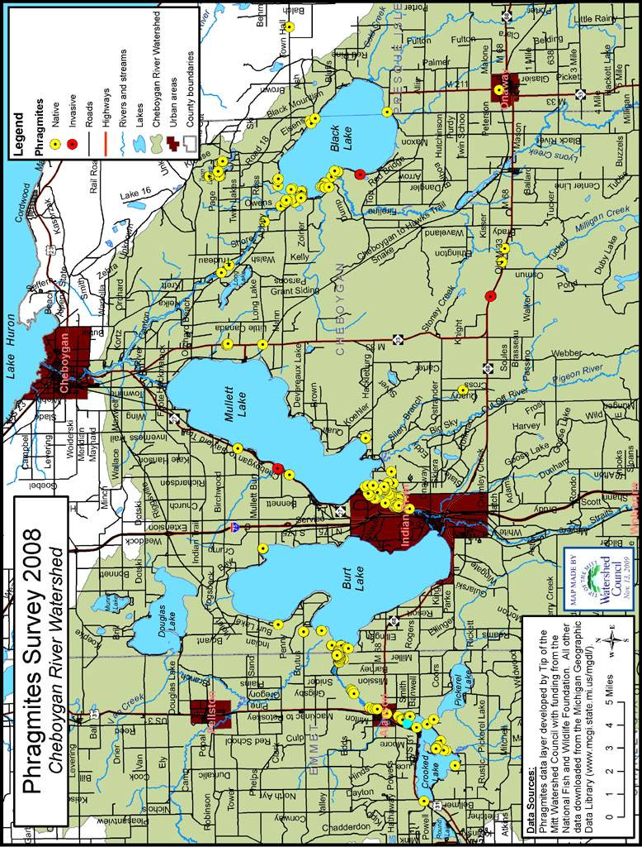

Figure 2. Quagga mussels in the Cheboygan River Watershed.
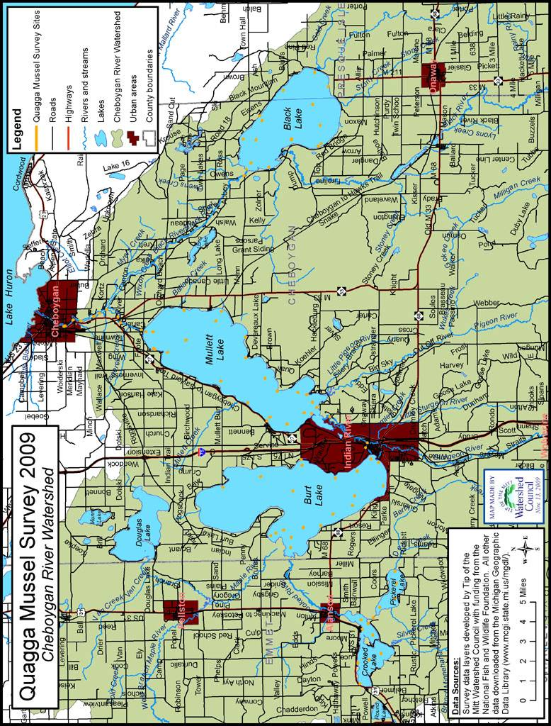
Figure 3. High priority areas for management.
