Stoney Creek Water Quality Summary
By Tip of the Mitt Watershed Council
426 Bay St.
Petoskey, MI 49740
231-347-1181
info@watershedcouncil.org

Water quality monitoring conducted by Black Lake Preservation Society and report written by
Tip of the Mitt Watershed Council
January 2020
Prepared for Black Lake Preservation Society

Introduction
Tip of the Mitt Watershed Council conducted water quality monitoring on six tributaries around Black Lake in 2018. The tributaries monitored included Cain’s Creek, Rainy River, Cold Creek, Stewart Creek, Fisher Creek, and Stoney Creek. Stoney Creek was found to have high nutrients after rain events. In addition to water quality monitoring, Harmful Algal Blooms (HABs) occurred on Black Lake in 2019 and 2020. Black Lake Preservation Society requested more targeted monitoring, which they were able to do with volunteers. The Watershed Council’s role in the project has been to provide sampling equipment, support for GIS and Survey123, and data analysis. Black Lake Preservation Society walked a portion of the creek, taking dissolved oxygen measurements and GPS points at features that may contribute to point source or nonpoint source pollution of the creek.

Results
  - Creek Survey
Seven types of features were found on the portion of Stoney Creek surveyed in August (Table 1, Figure 4). Sampling points were collected upstream and downstream of features when possible. The majority of sampling points were collected around tributaries. Three of the farming sites had signs of pollution including silt and algae. Four erosion sites were found upstream and downstream of County Line Rd (sites 16/17, 20, 24, and 27). Two are severe and require additional measurements to properly estimate pollution from sediments (20 and 27).
Table 1. Features found during a walking survey of the creek.
Feature Type | Frequency
Tributaries | 11
Aquatic Plants | 9
Road/stream crossings | 7
Farming | 5
Erosion | 5
Beaver Dams | 4
Houses | 3

  - Water Quality
Methods
Dissolved oxygen and temperature were collected with a YSI Model 55/25 Handheld Dissolved Oxygen and Temperature System by Black Lake Preservation Society volunteers from August 11 to August 25, 2020. The probe was inserted at mid-channel and mid-depth and allowed to stabilize. These parameters were collected at features that could contribute to nonpoint source pollution. Results were recorded at GPS locations using a Survey123 form. Survey123 records were assigned site identification numbers in post-processing.
Water samples were collected on August 29 after 0.83” of rain (recorded in Pellston, MI). 250 mL polyethylene bottles were filled at mid-depth and mid-channel at nine locations. Originally, monitoring was planned for fewer locations with more frequency during the field season, however time constraints limited water sample collection to one date.
Dissolved Oxygen
Stoney Creek’s cold-water fishery designation means it should have at least 7 mg/L of dissolved oxygen to support brook trout. The majority of Stoney Creek between the mouth and Allis Highway met the dissolved oxygen standards (Figure 5). Dissolved oxygen results ranged from 1.45 mg/L to 10.12 mg/L. Higher dissolved oxygen levels were associated with tributary inputs and aquatic vegetation. Dissolved oxygen levels less than 7 mg/L were mostly associated with beaver dams and road/stream crossings, which create pools and allow water to warm up.
Temperature
Stoney Creek is a cold-water stream that can support brook trout. According to EGLE Part 4 Water Quality Standards, the monthly maximum temperature for August for streams supporting cold-water fish are set at 68° Fahrenheit (20.0° Celsius). The majority of Stoney Creek met temperature standards except for a few sites at the mouth near Black Lake and a few sites at the end of the survey near County Line Rd (Figure 6). The sites that exceeded temperature standards were most commonly situation near road/stream crossings, beaver dams, and houses. Temperatures were similar to those recorded in August 2020.
Chloride
Chloride (Cl⁻) is found in table salt, in water softener salts, in some fertilizers, and used in the wintertime to de-ice roadways. Chloride in the water is a sign of human influences. Stoney Creek did not exceed Environmental Protection Agency thresholds for chronic or acute toxicity. Most water bodies in Northern Michigan have natural chloride levels of less than 25 mg/L and Stoney Creek chloride levels were higher than that from Twin Schools Rd. to Hutchinson HWY (Figure 1, Figure 7). Additionally, the marked increased between M-68 (10.92 mg/L) and Twin Schools Rd. (44.40 mg/L) is a concern. A salt storage barn located near Twin Schools Rd. could be the reason for heightened chloride in Stoney Creek if salt from the storage barn is getting into the creek. Chloride values at Stoney Creek were slightly lower in 2020 than in 2018 at the same locations (Table 2).

Figure 1. Chloride results on Stoney Creek (2020).
Phosphorus
According to EPA ecoregion recommendations, creeks with high water quality in this area should have total phosphorus of no more than 12 µg/L. Total phosphorus recommendations was exceeded at five sampling locations, specifically every location upstream of Allis Highway (Figure 2, Figure 7). Phosphorus results in 2020 were lower than the average for 2018 at the mouth and N. County Line Rd. Phosphorus results in 2020 were higher than the 2018 average at M-68 (Table 2).

Figure 2. Total phosphorus results on Stoney Creek (2020).

Nitrogen
EPA ecogion recommendations state that high quality creeks in this area should have no more than 440 440 µg/L of total nitrogen. Total nitrogen was exceeded at every sampling location (Figure 3, Figure 7). Total nitrogen declined from the upstream reaches towards the mouth. Total nitrogen in 2020 was above 2018 averages at the mouth and M-68 (Table 2).

Figure 3.Total nitrogen results on Stoney Creek (2020).
Table 2. Comparison of 2020 results to 2018 averages.
 | Location | 2018 Average | August 2020
Chloride | Mouth | 15.30428 | 13.992
 | N. County Line Rd. | 19.4484 | 15.939
 | M-68 | 14.6706 | 10.917
Total Nitrogen | Mouth | 382.8598 | 519.5521
 | N. County Line Rd. | 978.8273 | 533.7448
 | M-68 | 401.8163 | 935.0968
Total Phosphorus | Mouth | 10.461 | 8.7732
 | N. County Line Rd. | 77.22825 | 0.7915
 | M-68 | 5.960667 | 60.1061

  - Recommendations
- Results of this survey should be shared with the Cheboygan County Road Commission and Michigan Department of Environment, Great Lakes, and Energy.
- Watershed Council staff should inventory erosion sites 16/17, 20, 24, and 27.
- Black Lake Preservation Society should continue to walk the rest of the creek, as most of the water quality impairments seem to be coming from upstream areas.
- Results of this survey should be included in future watershed management planning efforts.
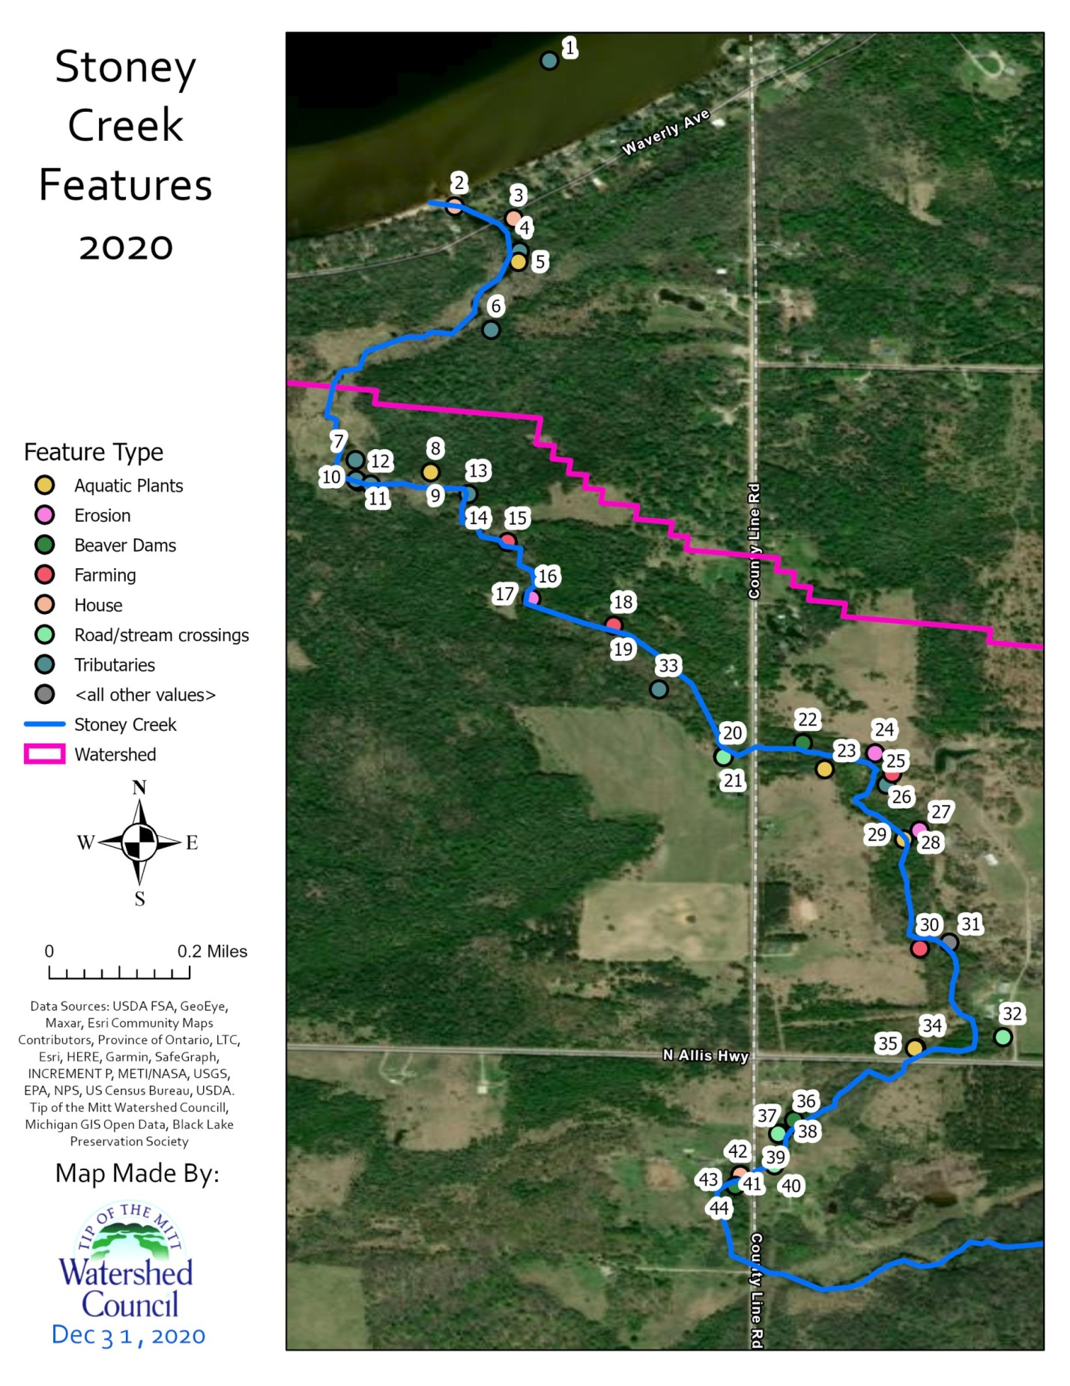
Figure 4. Locations and feature types on Stoney Creek (2020).
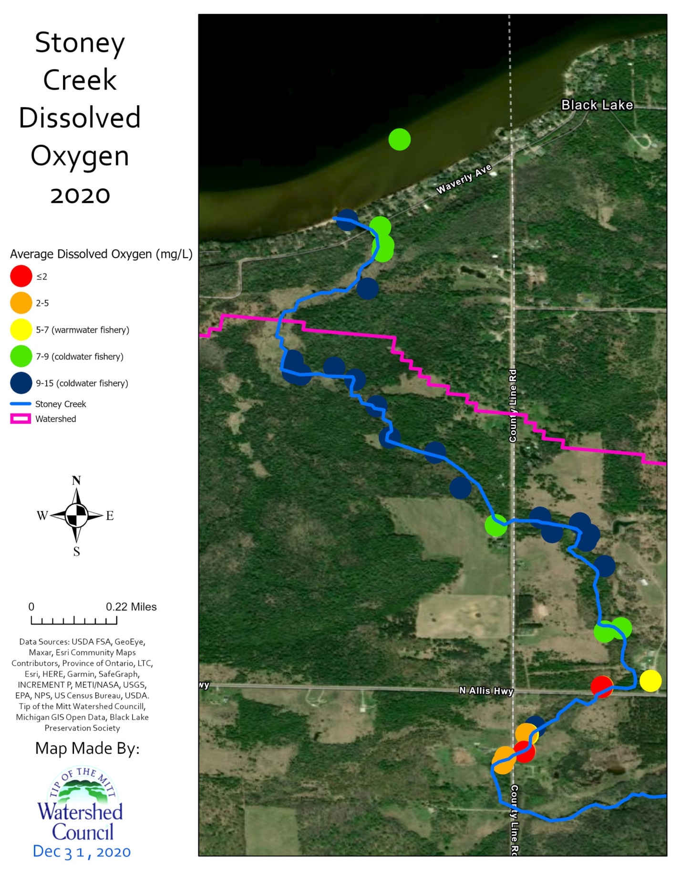
Figure 5. Dissolved oxygen collected on Stoney Creek (2020).
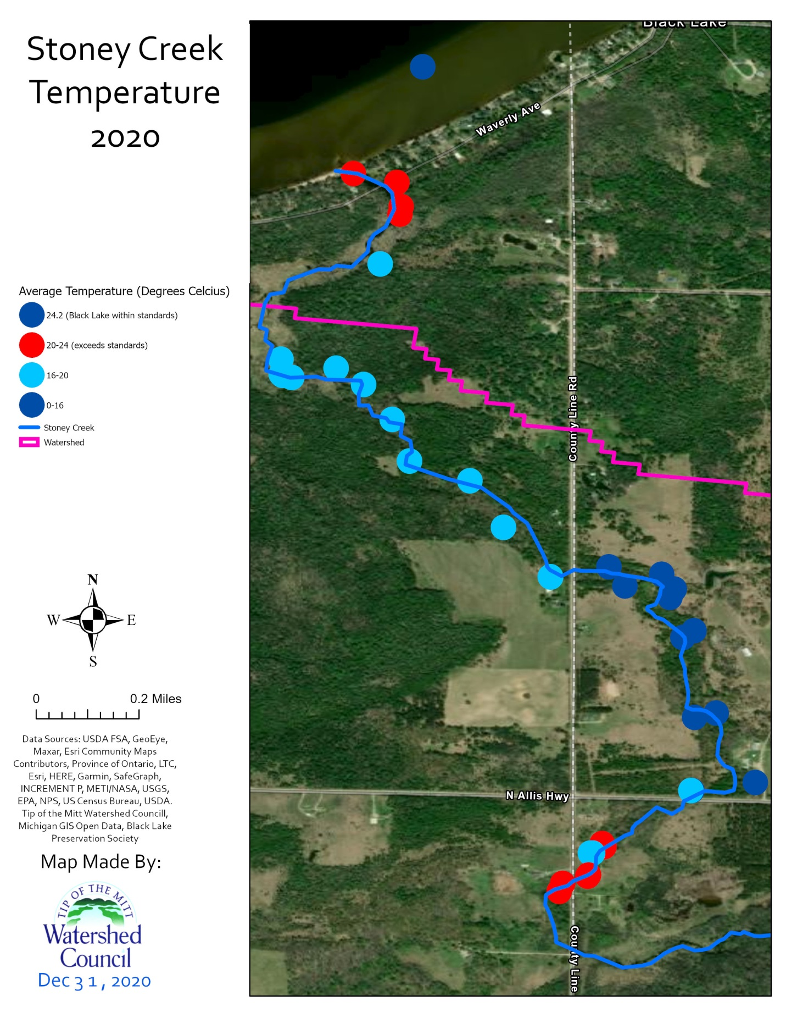
Figure 6. Temperature collected on Stoney Creek (2020).
  - 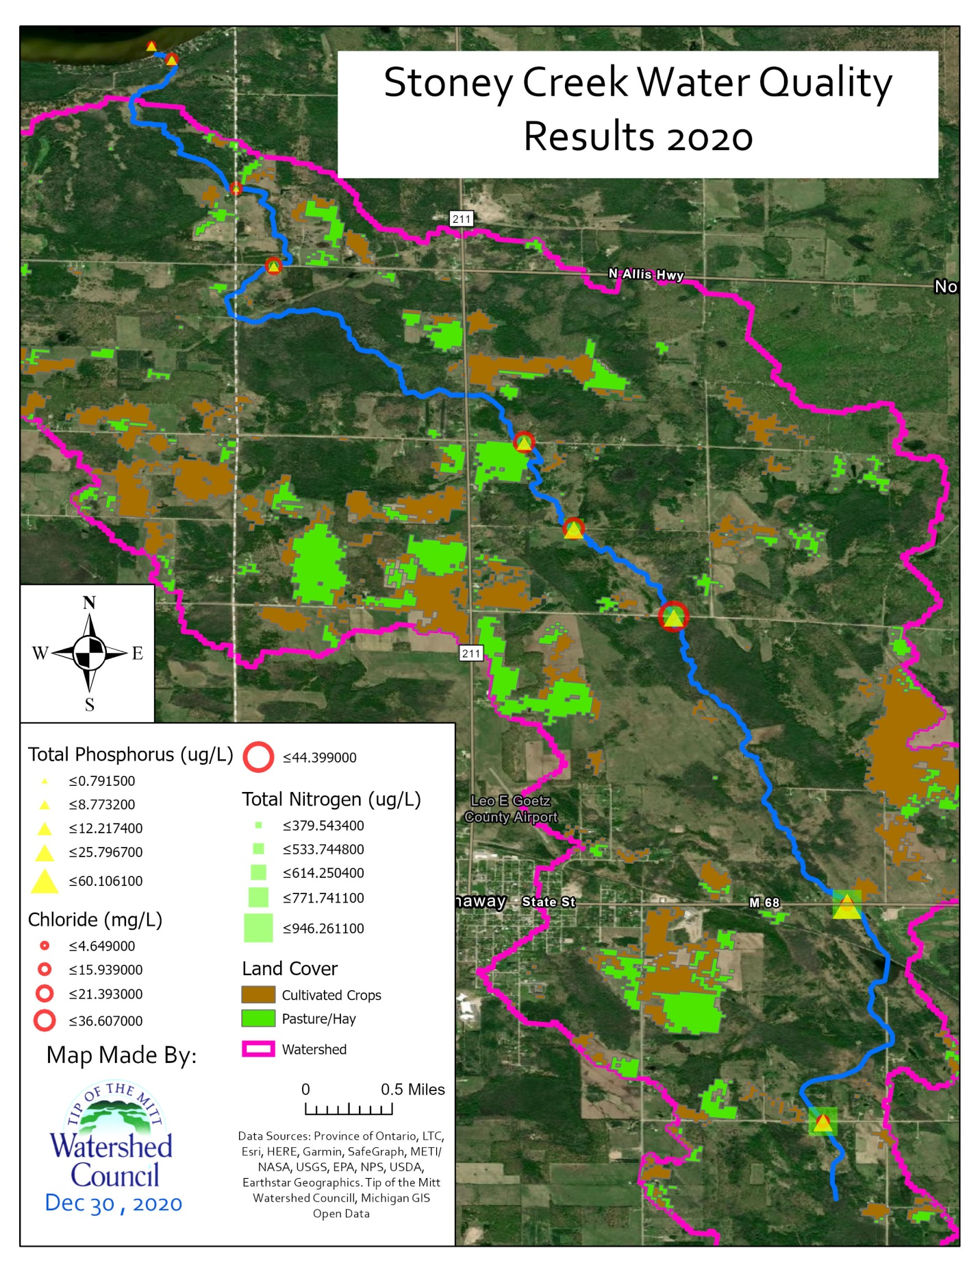
Figure 7. Water quality results collected on Stoney Creek (2020).

